User Fees and Subsidies Engagement Questions

Full Cost Principle

The City should have a complete understanding of how much it costs to provide a good or service before setting a fee

Principle details
- Direct, indirect, overhead, capital and administrative costs should be included.
- Where possible, non-monetary costs should be included.

How it works in practice
The City calculates the full cost of providing a good or service by looking at all costs associated with its delivery. Understanding the full cost provides a foundation for the other principles to be applied and a decision can be made on how best to fund the service (through fees, public funding, or a mix of both). Knowing the full cost of providing the service is also important to pursue funding from other orders of government. An example of how full cost is calculated is shown below:

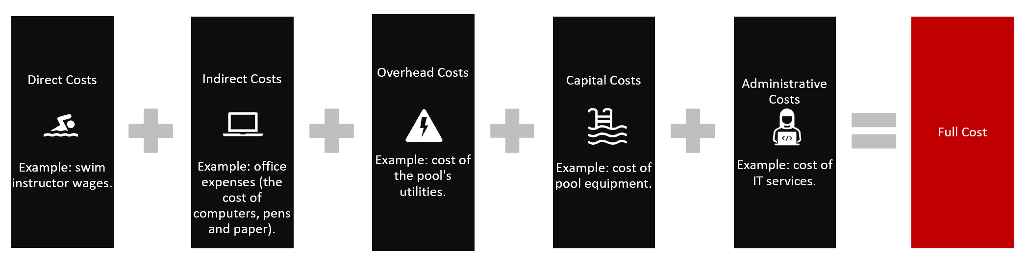

Is there anything else we should add to this principle?

Do you have any concerns about this principle?

Benefits Principle

Those who benefit from the use of a service should pay for that service
Principle details
- The City should assess the benefits provided by a good or service and determine how the service benefits both the community and the individual.
- The benefit to the individual should provide the basis of charging a fee.
- The proportion of the benefits to the community should be publicly funded.
- Pricing of goods or services may be structured to achieve community goals.

How it works in practice
The City assesses a service’s benefit to the community and to the individual user to determine how a service is funded. For example, when a person uses transit rather than a car, there is a community benefit (such as less traffic, reduced need for road maintenance and lower greenhouse gas emissions). There is also a benefit to the individual (transportation). As a result, a portion of transit should be publicly-funded and a portion paid by the individual using transit. This mix of funding encourages the use of services that, and through its use, all Calgarians benefit.
Is there anything else we should add to this principle?

Do you have any concerns about this principle?

Resource Efficiency Principle
City services should seek to maximize community benefits and fee revenue (as appropriate).
Principle details
- Public resources should be allocated to maximize the overall benefit to the community including striving to meet diverse needs.
- Fees for goods and services should be structured to encourage appropriate service use and evaluated relative to market conditions.

How it works in practice
The City uses limited public resources (such as land, buildings, facilities, funds, and equipment) to create the most benefit for Calgarians while addressing diverse needs and considering market conditions. This maximizes benefits to individuals and the community.
The pricing of fees should consider fees charged by others for similar goods or services, service demand, and availability of alternative services. For example, when setting fees and schedules for swimming, consideration should be
given to prices at private facilities and other municipalities; capacity and demand; and the opportunity to meet diverse needs (for example, providing swim times to meet specific cultural needs). This encourages the use of the facility, revenue generation and benefits to the community including meeting diverse needs.
Is there anything else we should add to this principle?

Do you have any concerns about this principle?

Ability to Pay Principle

All Calgarians should have the opportunity to access city goods and services.

Principle details
- The City should provide reduced rates or rebates to individuals and groups who are otherwise unable to purchase a city good or service.
- Reduced rates and rebates should be applied after full cost and pricing is understood.

How it works in practice
Services can offer reduced rates to people are not able to pay for a service due to their level of income. An example is a sliding scale for low-income transit passes where the less a person earns, the less they will have to pay. This principle also provides the reason for offering facility bookings (such as meeting rooms) at a reduced rate to non-profit groups.

Is there anything else we should add to this principle?

Do you have any concerns about this principle?

OVERARCHING CLOSING QUESTION:

Used together, do you think that the four draft principles can effectively guide how and when fees are applied to City services?

Is there anything else you’d like to add?

